Ćwiczenie nr 1

Metody Obliczeniowe W Nauce i Technice

**Krzysztof Tatar**

**Nr albumu: D/127984**

W zadaniu pierwszym została wybrana następująca funkcja:

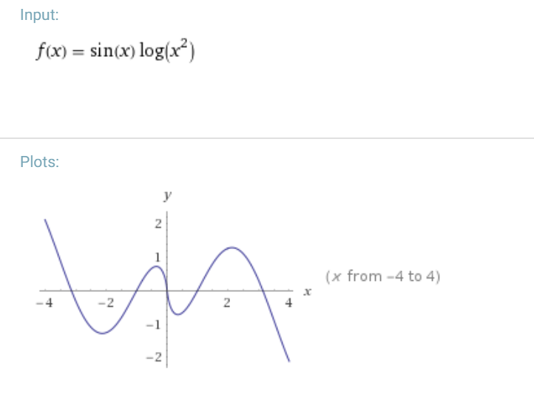

Wykres podanej funkcji.

|  |  |  |  |  |  |
| --- | --- | --- | --- | --- | --- |
| N | inttria | intpara | log(n) | log(błąd_inttria) | log(błąd_intpara) |
| 10 | 2,708210749 | 3,100440403 | 1 | -0,408826775 | -2,679038931 |
| 20 | 3,002382989 | 3,098476876 | 1,301029996 | -1,018066781 | -3,884728532 |
| 40 | 3,074453404 | 3,09835463 | 1,602059991 | -1,62242246 | -5,088721999 |
| 80 | 3,092379324 | 3,098346987 | 1,903089987 | -2,22702021 | -6,292776171 |
| 1000 | 3,098308301 | 3,098346478 |  |  |  |

Wykres błędu całkowania funkcji

W zadaniu drugim została wybrana następująca funkcja:



Wykres podanej funkcji.

|  |  |  |  |  |  |  |
| --- | --- | --- | --- | --- | --- | --- |
| N | newton | bisect | siecz | log(błąd_newton) | log(błąd_bisect) | log(błąd_siecz) |
| 1 | 0,345103217 | 0,25 | 0,128748 | -0,462050993 | -0,602059991 | -0,890260964 |
| 2 | 0,013256258 | 1,25E-01 | 0,011999 | -1,877579057 | -0,903089987 | -1,920845973 |
| 3 | 4,79E-05 | 0,0625 | 7,92E-04 | -4,319924968 | -1,204119983 | -3,101229898 |
| 4 | 6,37E-10 | 0,03125 | 5,03E-05 | -9,195734173 | -1,505149978 | -4,298026603 |
| 5 |  | 0,015625 | 3,19E-06 |  | -1,806179974 | -5,495925698 |
| 6 |  | 0,0078125 | 2,02E-07 |  | -2,10720997 | -6,693894946 |
| 7 |  | 0,00390625 | 1,28E-08 |  | -2,408239965 | -7,891868638 |
| 8 |  | 0,001953125 | 8,13E-10 |  | -2,709269961 | -9,089842621 |
| 9 |  | 9,77E-04 | 5,15E-11 |  | -3,010299957 | -10,28781728 |
| 10 |  | 4,88E-04 | 3,27E-12 |  | -3,311329952 | -11,48582902 |
| 11 |  | 2,44E-04 | 2,08E-13 |  | -3,612359948 | -12,68228393 |
| 12 |  | 1,22E-04 | 1,24E-14 |  | -3,913389944 | -13,90537175 |
| 13 |  | 6,10E-05 | 1,33E-15 |  | -4,214419939 | -14,87540852 |
| 14 |  | 3,05E-05 |  |  | -4,515449935 |  |
| 15 |  | 1,53E-05 |  |  | -4,816479931 |  |
| 16 |  | 7,63E-06 |  |  | -5,117509926 |  |
| 17 |  | 3,81E-06 |  |  | -5,418539922 |  |
| 18 |  | 1,91E-06 |  |  | -5,719569918 |  |
| 19 |  | 9,54E-07 |  |  | -6,020599913 |  |
| 20 |  | 4,77E-07 |  |  | -6,321629909 |  |
| 21 |  | 2,38E-07 |  |  | -6,622659905 |  |
| 22 |  | 1,19E-07 |  |  | -6,9236899 |  |
| 23 |  | 5,96E-08 |  |  | -7,224719896 |  |
| 24 |  | 2,98E-08 |  |  | -7,525749892 |  |
| 25 |  | 1,49E-08 |  |  | -7,826779887 |  |
| 26 |  | 7,45E-09 |  |  | -8,127809883 |  |
| 27 |  | 3,73E-09 |  |  | -8,428839879 |  |
| 28 |  | 1,86E-09 |  |  | -8,729869874 |  |
| 29 |  | 9,31E-10 |  |  | -9,03089987 |  |
| 30 |  | 4,66E-10 |  |  | -9,331929866 |  |
| 31 |  | 2,33E-10 |  |  | -9,632959861 |  |
| 32 |  | 1,16E-10 |  |  | -9,933989857 |  |
| 33 |  | 5,82E-11 |  |  | -10,23501985 |  |
| 34 |  | 2,91E-11 |  |  | -10,53604985 |  |
| 35 |  | 1,46E-11 |  |  | -10,83707984 |  |
| 36 |  | 7,28E-12 |  |  | -11,13810984 |  |
| 37 |  | 3,64E-12 |  |  | -11,43913984 |  |
| 38 |  | 1,82E-12 |  |  | -11,74016983 |  |
| 39 |  | 9,09E-13 |  |  | -12,04119983 |  |
| 40 |  | 4,55E-13 |  |  | -12,34222982 |  |
| 41 |  | 2,27E-13 |  |  | -12,64325982 |  |
| 42 |  | 1,14E-13 |  |  | -12,94428981 |  |
| 43 |  | 5,68E-14 |  |  | -13,24531981 |  |
| 44 |  | 2,84E-14 |  |  | -13,5463498 |  |
| 45 |  | 1,42E-14 |  |  | -13,8473798 |  |

**Zadanie 3**

W zadaniu wykorzystałem następującą macierz:

A =

1     2     3     4

2    13     5     6

3     5     2     7

4     6     7     5

Macierz V:

|  |  |  |  |
| --- | --- | --- | --- |
| -0.060492027265623 | 0.881968436306589 | 0.402642264800257 | 0.237384916523197 |
| 0.005822820779533 | 0.123625443005318 | -0.690236215317480 | 0.712921322211721 |
| -0.764837592020178 | -0.330663683497882 | 0.364084678733480 | 0.416085727897422 |
| 0.641350346712497 | -0.312265841257513 | 0.478430266990143 | 0.512117424799467 |

Macierz M:

|  |  |  |  |
| --- | --- | --- | --- |
| -3.670603137631673 | 0 | 0 | 0 |
| 0 | -1.260629119407596 | 0 | 0 |
| 0 | 0 | 5.037089038162527 | 0 |
| 0 | 0 | 0 | 20.894143218876739 |

Wartości własne wybranej macierzy. Wartości z funkcji eig():

|  |  |  |
| --- | --- | --- |
| Qi | Qj | Qi x Qj |
| 1 | 2 | -2.775557561562891e-17 |
| 1 | 3 | 0 |
| 1 | 4 | 1.665334536937735e-16 |
| 2 | 3 | -1.110223024625157e-16 |
| 2 | 4 | -5.551115123125783e-17 |
| 3 | 4 | -8.326672684688674e-17 |

|  |  |  |  |
| --- | --- | --- | --- |
| 𝑨 × 𝑽 − 𝑽 × 𝑴 | | | |
| 1.9429e-015 | -6.6613e-016 | 0.0000e+000 | 8.8818e-016 |
| -1.3531e-015 | -1.6098e-015 | 8.8818e-016 | 3.5527e-015 |
| 2.6645e-015 | -1.4988e-015 | -2.4425e-015 | 5.3291e-015 |
| 8.8818e-016 | -7.2164e-016 | 4.4409e-016 | 1.7764e-015 |

**Zadanie 4**

a =

42 6 8 10

7 12 2 4

8 2 37 2

9 4 2 22

b =

1

1

1

5

**Wnioski**

Powyższy wykres potwierdza liniową zbieżność algorytmu. Nie ma żadnych odchyleń w kolejnych iteracjach.